5.50: a) b) The magnitude of the radial force is (to the nearest Newton), so the apparent weight at the top is 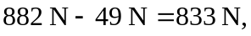 and at the bottom is 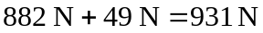.
c) For apparent weightlessness, the radial acceleration at the top is equal to g in magnitude. Using this in Eq. (5.16) and solving for T gives
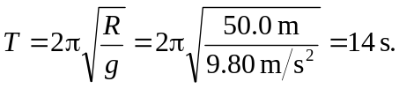
d) At the bottom, the apparent weight is twice the weight, or 1760 N.

